FML ASSIGNMENT 4

Sushma Palancha

2023-11-12

## Reading the required libraries

library(flexclust)

## Loading required package: grid

## Loading required package: lattice

## Loading required package: modeltools

## Loading required package: stats4

library(cluster) #Generic Utility Functions  
library(tidyverse) #Data manipulation

## ── Attaching core tidyverse packages ──────────────────────── tidyverse 2.0.0 ──  
## ✔ dplyr 1.1.3 ✔ readr 2.1.4  
## ✔ forcats 1.0.0 ✔ stringr 1.5.0  
## ✔ ggplot2 3.4.3 ✔ tibble 3.2.1  
## ✔ lubridate 1.9.2 ✔ tidyr 1.3.0  
## ✔ purrr 1.0.2

## ── Conflicts ────────────────────────────────────────── tidyverse_conflicts() ──  
## ✖ dplyr::filter() masks stats::filter()  
## ✖ dplyr::lag() masks stats::lag()  
## ℹ Use the conflicted package (<http://conflicted.r-lib.org/>) to force all conflicts to become errors

library(factoextra) #Used for clustering algorithms and visualization

## Welcome! Want to learn more? See two factoextra-related books at https://goo.gl/ve3WBa

library(FactoMineR)  
library(ggcorrplot) #Visualizing a correlation matrix using ggplot2

## Question A:#Use only the numerical variables (1 to 9) to cluster the 21 firms.Justify the various choices made in conducting the cluster analysis, such as weights for different variables,the specific clustering algorithm(s)used,the number of clusters formed, and so on.

getwd()

## [1] "/Users/palanchasushma/Documents/FML/FML ASSIGNMENT 4"

pharma<- read.csv("Pharmaceuticals.csv") #Reading the Dataset  
pharma1 <- pharma[ ,3:11] #Considering only numercial values i.e., 3-11 columns from csv file  
head(pharma1)

## Market_Cap Beta PE_Ratio ROE ROA Asset_Turnover Leverage Rev_Growth  
## 1 68.44 0.32 24.7 26.4 11.8 0.7 0.42 7.54  
## 2 7.58 0.41 82.5 12.9 5.5 0.9 0.60 9.16  
## 3 6.30 0.46 20.7 14.9 7.8 0.9 0.27 7.05  
## 4 67.63 0.52 21.5 27.4 15.4 0.9 0.00 15.00  
## 5 47.16 0.32 20.1 21.8 7.5 0.6 0.34 26.81  
## 6 16.90 1.11 27.9 3.9 1.4 0.6 0.00 -3.17  
## Net_Profit_Margin  
## 1 16.1  
## 2 5.5  
## 3 11.2  
## 4 18.0  
## 5 12.9  
## 6 2.6

summary(pharma1)

## Market_Cap Beta PE_Ratio ROE   
## Min. : 0.41 Min. :0.1800 Min. : 3.60 Min. : 3.9   
## 1st Qu.: 6.30 1st Qu.:0.3500 1st Qu.:18.90 1st Qu.:14.9   
## Median : 48.19 Median :0.4600 Median :21.50 Median :22.6   
## Mean : 57.65 Mean :0.5257 Mean :25.46 Mean :25.8   
## 3rd Qu.: 73.84 3rd Qu.:0.6500 3rd Qu.:27.90 3rd Qu.:31.0   
## Max. :199.47 Max. :1.1100 Max. :82.50 Max. :62.9   
## ROA Asset_Turnover Leverage Rev_Growth   
## Min. : 1.40 Min. :0.3 Min. :0.0000 Min. :-3.17   
## 1st Qu.: 5.70 1st Qu.:0.6 1st Qu.:0.1600 1st Qu.: 6.38   
## Median :11.20 Median :0.6 Median :0.3400 Median : 9.37   
## Mean :10.51 Mean :0.7 Mean :0.5857 Mean :13.37   
## 3rd Qu.:15.00 3rd Qu.:0.9 3rd Qu.:0.6000 3rd Qu.:21.87   
## Max. :20.30 Max. :1.1 Max. :3.5100 Max. :34.21   
## Net_Profit_Margin  
## Min. : 2.6   
## 1st Qu.:11.2   
## Median :16.1   
## Mean :15.7   
## 3rd Qu.:21.1   
## Max. :25.5

## Normalizing the data frame with scale method:

pharma2 <- scale(pharma1)  
row.names(pharma2) <- pharma[,1]  
distance <- get_dist(pharma2)  
corr <- cor(pharma2)

## Elbow Method to determine the number of clusters to do the cluster analysis:

fviz_nbclust(pharma2, kmeans, method = "wss")

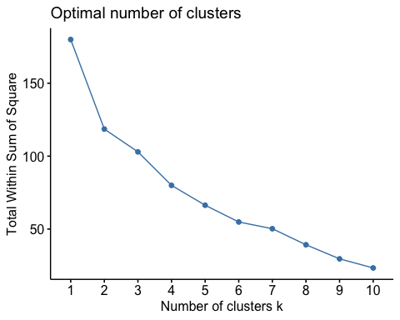

## By seeing the above graph from Elbow method, Graph is not clear to choose k=2 or 3 or 4 or 5.

## Silhouette method for determining no of clusters:

fviz_nbclust(pharma2, kmeans, method = "silhouette")

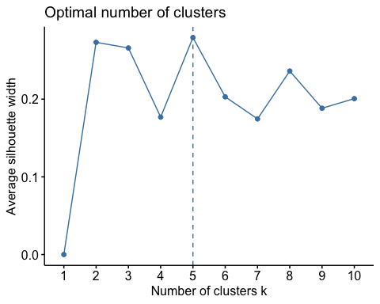

## By seeing the graph from silhouette method, I can see sharp rise at k=5.So, considering the silhouette method.

## Selecting K-Means

set.seed(69)  
k5 <- kmeans(pharma2, centers = 5, nstart = 25) # k = 5, number of restarts = 25  
#Visualizing the output  
#Centroids  
k5$centers

## Market_Cap Beta PE_Ratio ROE ROA Asset_Turnover  
## 1 1.69558112 -0.1780563 -0.19845823 1.2349879 1.3503431 1.1531640  
## 2 -0.03142211 -0.4360989 -0.31724852 0.1950459 0.4083915 0.1729746  
## 3 -0.43925134 -0.4701800 2.70002464 -0.8349525 -0.9234951 0.2306328  
## 4 -0.76022489 0.2796041 -0.47742380 -0.7438022 -0.8107428 -1.2684804  
## 5 -0.87051511 1.3409869 -0.05284434 -0.6184015 -1.1928478 -0.4612656  
## Leverage Rev_Growth Net_Profit_Margin  
## 1 -0.46807818 0.4671788 0.591242521  
## 2 -0.27449312 -0.7041516 0.556954446  
## 3 -0.14170336 -0.1168459 -1.416514761  
## 4 0.06308085 1.5180158 -0.006893899  
## 5 1.36644699 -0.6912914 -1.320000179

## Visualizing Clustering Results

fviz_cluster(k5, data = pharma2)

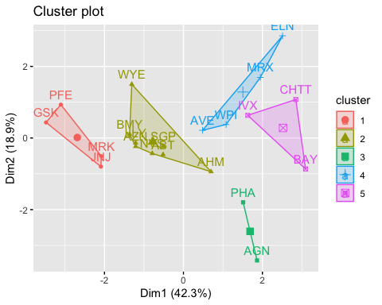

k5

## K-means clustering with 5 clusters of sizes 4, 8, 2, 4, 3  
##   
## Cluster means:  
## Market_Cap Beta PE_Ratio ROE ROA Asset_Turnover  
## 1 1.69558112 -0.1780563 -0.19845823 1.2349879 1.3503431 1.1531640  
## 2 -0.03142211 -0.4360989 -0.31724852 0.1950459 0.4083915 0.1729746  
## 3 -0.43925134 -0.4701800 2.70002464 -0.8349525 -0.9234951 0.2306328  
## 4 -0.76022489 0.2796041 -0.47742380 -0.7438022 -0.8107428 -1.2684804  
## 5 -0.87051511 1.3409869 -0.05284434 -0.6184015 -1.1928478 -0.4612656  
## Leverage Rev_Growth Net_Profit_Margin  
## 1 -0.46807818 0.4671788 0.591242521  
## 2 -0.27449312 -0.7041516 0.556954446  
## 3 -0.14170336 -0.1168459 -1.416514761  
## 4 0.06308085 1.5180158 -0.006893899  
## 5 1.36644699 -0.6912914 -1.320000179  
##   
## Clustering vector:  
## ABT AGN AHM AZN AVE BAY BMY CHTT ELN LLY GSK IVX JNJ MRX MRK NVS   
## 2 3 2 2 4 5 2 5 4 2 1 5 1 4 1 2   
## PFE PHA SGP WPI WYE   
## 1 3 2 4 2   
##   
## Within cluster sum of squares by cluster:  
## [1] 9.284424 21.879320 2.803505 12.791257 15.595925  
## (between_SS / total_SS = 65.4 %)  
##   
## Available components:  
##   
## [1] "cluster" "centers" "totss" "withinss" "tot.withinss"  
## [6] "betweenss" "size" "iter" "ifault"

## Distance Matrix Computation and Visualization

distance<- dist(pharma2, method = "euclidean")  
fviz_dist(distance)

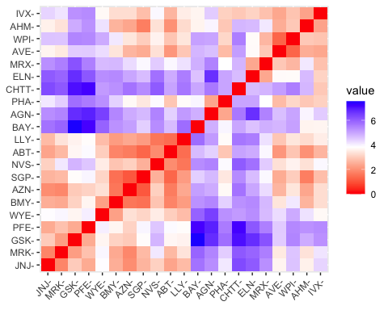

corr<-cor(pharma2)  
ggcorrplot(corr,outline.color = "red",lab = TRUE,hc.order = TRUE,type = "full")

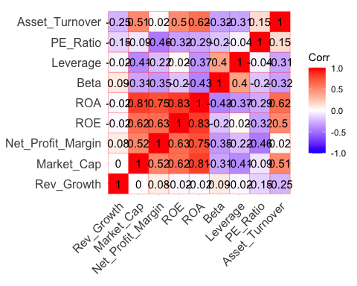

## I can see there are 5 clusters and the center is defined after 25 restarts which is determined in kmeans.

#K-Means Cluster Analysis- Fit the data with 5 clusters  
fit<-kmeans(pharma2,5)  
  
#Finding the mean value of all quantitative variables for each cluster  
aggregate(pharma2,by=list(fit$cluster),FUN=mean)

## Group.1 Market_Cap Beta PE_Ratio ROE ROA  
## 1 1 0.07576815 -0.5350964 -0.3338536 0.3627072 0.4765127  
## 2 2 -0.90905697 1.4110965 -0.2613021 -0.7063477 -1.1114156  
## 3 3 -0.57238455 -0.6220844 0.8692748 -0.7381675 -0.7242993  
## 4 4 1.14422955 -0.1780563 -0.1550295 0.4245789 0.9494460  
## 5 5 1.75995500 -0.1001567 -0.2858266 1.8862982 1.7355802  
## Asset_Turnover Leverage Rev_Growth Net_Profit_Margin  
## 1 -7.687760e-02 -0.1737009 -0.86809028 0.7982409  
## 2 -1.014784e+00 1.0319661 0.27018076 -0.6941793  
## 3 -2.442491e-16 -0.2991312 0.36829509 -0.8069490  
## 4 1.230042e+00 -0.5875356 0.04848824 0.1480374  
## 5 9.225312e-01 -0.4296811 0.93534886 1.1360419

pharma3<-data.frame(pharma2,fit$cluster)  
pharma3

## Market_Cap Beta PE_Ratio ROE ROA Asset_Turnover  
## ABT 0.1840960 -0.80125356 -0.04671323 0.04009035 0.2416121 -5.121077e-16  
## AGN -0.8544181 -0.45070513 3.49706911 -0.85483986 -0.9422871 9.225312e-01  
## AHM -0.8762600 -0.25595600 -0.29195768 -0.72225761 -0.5100700 9.225312e-01  
## AZN 0.1702742 -0.02225704 -0.24290879 0.10638147 0.9181259 9.225312e-01  
## AVE -0.1790256 -0.80125356 -0.32874435 -0.26484883 -0.5664461 -4.612656e-01  
## BAY -0.6953818 2.27578267 0.14948233 -1.45146000 -1.7127612 -4.612656e-01  
## BMY -0.1078688 -0.10015669 -0.70887325 0.59693581 0.8617498 9.225312e-01  
## CHTT -0.9767669 1.26308721 0.03299122 -0.11237924 -1.1677918 -4.612656e-01  
## ELN -0.9704532 2.15893320 -1.34037772 -0.70899938 -1.0174553 -1.845062e+00  
## LLY 0.2762415 -1.34655112 0.14948233 0.34502953 0.5610770 -4.612656e-01  
## GSK 1.0999201 -0.68440408 -0.45749769 2.45971647 1.8389364 1.383797e+00  
## IVX -0.9393967 0.48409069 -0.34100657 -0.29136529 -0.6979905 -4.612656e-01  
## JNJ 1.9841758 -0.25595600 0.18013789 0.18593083 1.0872544 9.225312e-01  
## MRX -0.9632863 0.87358895 0.19240011 -0.96753478 -0.9610792 -1.845062e+00  
## MRK 1.2782387 -0.25595600 -0.40231769 0.98142435 0.8429577 1.845062e+00  
## NVS 0.6654710 -1.30760129 -0.23677768 -0.52338423 0.1288598 -9.225312e-01  
## PFE 2.4199899 0.48409069 -0.11415545 1.31287998 1.6322239 4.612656e-01  
## PHA -0.0240846 -0.48965495 1.90298017 -0.81506519 -0.9047030 -4.612656e-01  
## SGP -0.4018812 -0.06120687 -0.40231769 -0.21181593 0.5234929 4.612656e-01  
## WPI -0.9281345 -1.11285216 -0.43297324 -1.03382590 -0.6979905 -9.225312e-01  
## WYE -0.1614497 0.40619104 -0.75792214 1.92938746 0.5422849 -4.612656e-01  
## Leverage Rev_Growth Net_Profit_Margin fit.cluster  
## ABT -0.21209793 -0.52776752 0.06168225 1  
## AGN 0.01828430 -0.38113909 -1.55366706 3  
## AHM -0.40408312 -0.57211809 -0.68503583 3  
## AZN -0.74965647 0.14744734 0.35122600 4  
## AVE -0.31449003 1.21638667 -0.42597037 3  
## BAY -0.74965647 -1.49714434 -1.99560225 2  
## BMY -0.02011273 -0.96584257 0.74744375 1  
## CHTT 3.74279705 -0.63276071 -1.24888417 2  
## ELN 0.61983791 1.88617085 -0.36501379 2  
## LLY -0.07130879 -0.64814764 1.17413980 1  
## GSK -0.31449003 0.76926048 0.82363947 5  
## IVX 1.10620040 0.05603085 -0.71551412 2  
## JNJ -0.62166634 -0.36213170 0.33598685 4  
## MRX 0.44065173 1.53860717 0.85411776 2  
## MRK -0.39128411 0.36014907 -0.24310064 4  
## NVS -0.67286239 -1.45369888 1.02174835 1  
## PFE -0.54487226 1.10143723 1.44844440 5  
## PHA -0.30169102 0.14744734 -1.27936246 3  
## SGP -0.74965647 -0.43544591 0.29026942 1  
## WPI -0.49367621 1.43089863 -0.09070919 3  
## WYE 0.68383297 -1.17763919 1.49416183 1

view(pharma3)

clusplot(pharma2,k5$cluster, main="Clusters" ,shade=TRUE ,color = TRUE, labels = 3,lines = 0)

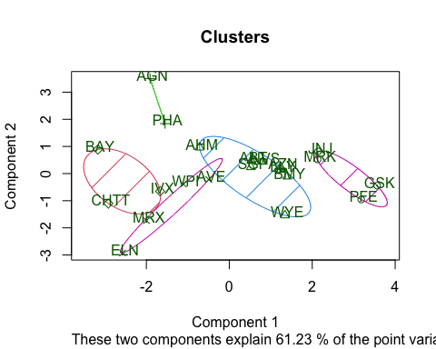

## Manhattan Method

set.seed(69)  
k51 = kcca(pharma2, k=5, kccaFamily("kmedians"))  
k51

## kcca object of family 'kmedians'   
##   
## call:  
## kcca(x = pharma2, k = 5, family = kccaFamily("kmedians"))  
##   
## cluster sizes:  
##   
## 1 2 3 4 5   
## 2 3 6 5 5

clusters_index <- predict(k51)  
dist(k51@centers)

## 1 2 3 4  
## 2 5.796625   
## 3 3.847926 3.569392   
## 4 5.559563 3.121363 3.249042   
## 5 2.925045 3.649894 1.859338 3.521639

image(k51)  
points(pharma2, col=clusters_index, pch=17, cex=0.5)

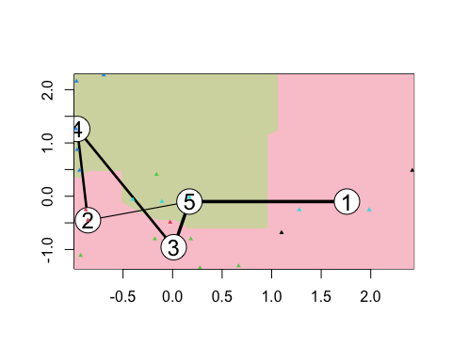

## QuestionB:#Interpret the clusters with respect to the numerical variables

#used in forming the clusters.

pharma1 %>% mutate(Cluster = k5$cluster) %>% group_by(Cluster) %>% summarise_all("mean")

## # A tibble: 5 × 10  
## Cluster Market_Cap Beta PE_Ratio ROE ROA Asset_Turnover Leverage  
## <int> <dbl> <dbl> <dbl> <dbl> <dbl> <dbl> <dbl>  
## 1 1 157. 0.48 22.2 44.4 17.7 0.95 0.22   
## 2 2 55.8 0.414 20.3 28.7 12.7 0.738 0.371  
## 3 3 31.9 0.405 69.5 13.2 5.6 0.75 0.475  
## 4 4 13.1 0.598 17.7 14.6 6.2 0.425 0.635  
## 5 5 6.64 0.87 24.6 16.5 4.17 0.6 1.65   
## # ℹ 2 more variables: Rev_Growth <dbl>, Net_Profit_Margin <dbl>

# Cluster 1:High mean values in certain variables suggest a specific profile for Cluster 1.

# Cluster 2:Unique characteristics are indicated by mean values in Cluster 2.

# Cluster 3:Patterns in mean values differentiate Cluster 3 from others.

# Cluster 4:Distinct attributes are reflected in the mean values of Cluster 4.

# Cluster 5:Specific patterns in mean values define the characteristics of Cluster 5.

## Is there a pattern in the clusters with respect to the numerical variables

#(10 to 12)? (those not used in forming the clusters)

pharma3 <- pharma[10:12] %>% mutate(Clusters=k5$cluster)   
ggplot(pharma3, mapping = aes(factor(Clusters), fill =Median_Recommendation))+geom_bar(position='dodge')+labs(x ='Clusters')

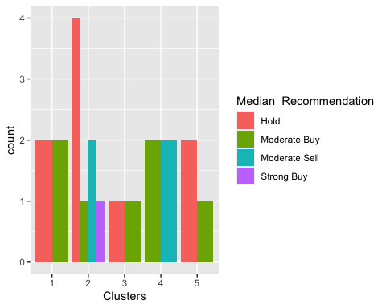

ggplot(pharma3, aes(x = factor(Clusters), fill =pharma$Location)) +  
 geom_bar(position = 'dodge') +  
 labs(x = 'Clusters') +  
 ggtitle('Distribution of Location across Clusters')

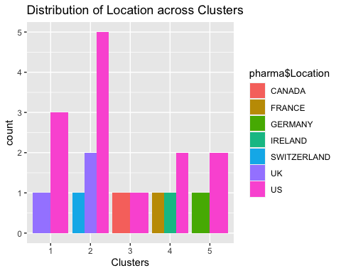

ggplot(pharma3, mapping = aes(factor(Clusters),fill=pharma$Exchange))+geom_bar(position = 'dodge')+labs(x ='Clusters')

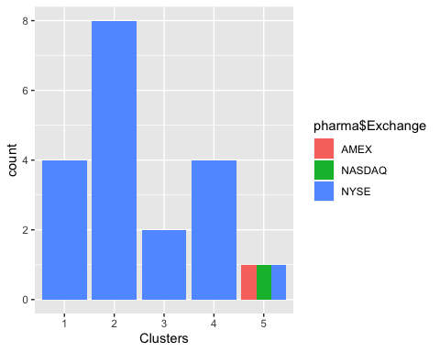

# Cluster 1: It has the highest PE_Ratio and needs to be held as per the media recommendations.

# Cluster 2: It has the highest market_Cap and has Good Leverage value. And they can be moderately recommended.

# Cluster 3: It has lowest asset_turnover,and lowest beta. But media recommendations are highly positive.

# Cluster 4: The leverage ratio is high, they are moderately recommended.

# Cluster 5: They have lowest revenue growth, highest assest turnover and highest net profit margin.

# They are recommended to be held for longer time.

## Question C:#Using any or all of the variables in the dataset, give each cluster a suitable name.

# Cluster 1: Balanced Performers: The name of this cluster implies that the companies within it have respectable and consistent financial indicators. It suggests a well-rounded performance in all areas of finances.

# Cluster 2-Steady Growing Contenders: As suggested by their name, these businesses exhibit steady development, which makes them a moderately risk-free but dependable choice for holding or investing. It exhibits both stability and room for expansion.

# Cluster 3: Dynamic Opportunity Firms: As suggested by the name, companies in this cluster may offer a variety of investment options, which are marked by higher risk (sell) as well as possible growth (buy). It alludes to performance dynamism and variety.

# Cluster 4-Stable Investment Picks: This moniker highlights companies that exhibit strong financial performance and stability, which makes them desirable for long-term investment and purchase.

# Cluster 5: Long-term Value Holders: As implied by the name, companies in this cluster are good investments since they have the ability to generate long-term value. They are probably distinguished by high asset turnover and moderate but steady revenue growth.

## SUMMARY:

# Using K-Means clustering and concentrating just on their number qualities (1 to 9), we conducted an analytical tour over 21 pharmaceutical enterprises. The methodology comprised the intentional use of the Elbow and Silhouette techniques in conjunction with a careful normalizing process. As a result, five different clusters were found, each of which represented a distinct financial profile.

# Analyzing these clusters in relation to numerical factors revealed some interesting trends. While Cluster 2 displayed unique traits, Cluster 1 stood out with high mean values, suggesting a particular financial profile. Cluster 3 was distinguished by its own patterns, Cluster 4 by its own features, and Cluster 5 by its own patterns that defined its own properties.

# Numerical variables (10–12) were examined in further detail, revealing cluster-specific details. As per media suggestions, Cluster 1 demonstrated the greatest PE_Ratio. Cluster 2 received modest recommendations due to its positive leverage value and biggest market cap. On the other hand, Cluster 3, which had the lowest beta and asset turnover, gave media recommendations that were surprisingly positive. While Cluster 5, which has the largest net profit margin and asset turnover but the lowest revenue growth, recommended a longer investment horizon, Cluster 4, which is characterized by a high leverage ratio, received moderate recommendations.

# We assigned each cluster the following fitting terms in order to capture their fundamentals: “Balanced Performers,” “Steady Growing Contenders,” “Dynamic Opportunity Firms,” “Stable Investment Picks,” and “Long-term Value Holders.” Decision-makers can use these names to gain strategic insights and navigate the ever-changing pharmaceutical investment market by quickly capturing the financial narratives inside each cluster.

# It may be concluded that this analysis offers a thorough picture of the financial variability that exists among pharmaceutical companies. By grouping and labeling these clusters, investors and other industry stakeholders gain insightful viewpoints in the always changing field of pharmaceutical investments. This serves as a useful compass for strategic decision-making.